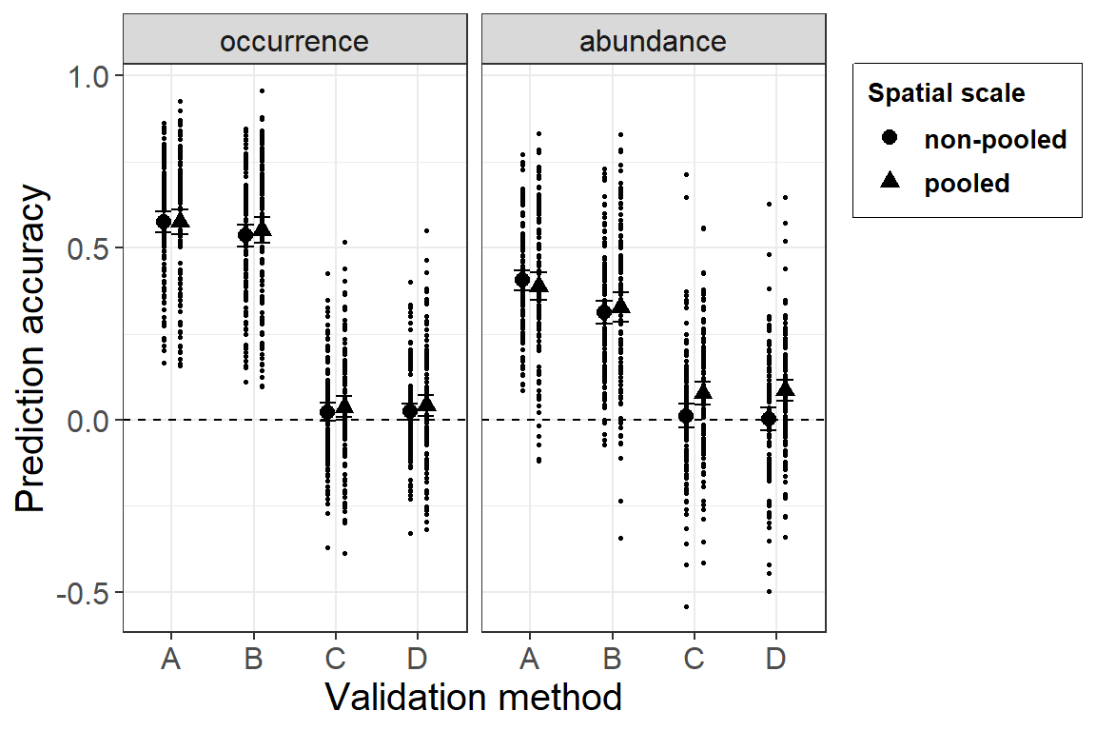
PA-aineisto:
Ensimmäinen analyysi:
Mallit:
A1=lme(accuracy~method*pool,data=poolresPA,random=~1|species,method="ML",na.action="na.exclude")
A2=lme(accuracy~method+pool,data=poolresPA,random=~1|species,method="ML",na.action="na.exclude")
A3=lme(accuracy~method,data=poolresPA,random=~1|species,method="ML",na.action="na.exclude")
A4=lme(accuracy~pool,data=poolresPA,random=~1|species,method="ML",na.action="na.exclude")

AIC-vertailu:
## df AIC
## A1 10 -1000.4569
## A2 7 -1005.6737
## A3 6 -1005.4586
## A4 4 504.8985

A3 summary:
Linear mixed-effects model fit by REML
## Data: poolresPA
## AIC BIC logLik
## -976.3323 -947.1558 494.1661
##
## Random effects:
## Formula: ~1 | species
## (Intercept) Residual
## StdDev: 0.1159061 0.1255142
##
## Fixed effects: accuracy ~ method
## Value Std.Error DF t-value p-value
## (Intercept) 0.5748204 0.01332640 837 43.13397 0.000
## methodB -0.0315642 0.01145783 837 -2.75482 0.006
## methodC -0.5441671 0.01145783 837 -47.49303 0.000
## methodD -0.5419361 0.01145783 837 -47.29831 0.000
## Correlation:
## (Intr) methdB methdC
## methodB -0.43
## methodC -0.43 0.50
## methodD -0.43 0.50 0.50
##
## Standardized Within-Group Residuals:
## Min Q1 Med Q3 Max
## -3.09495180 -0.61252190 0.06172091 0.62455600 3.40626329
##
## Number of Observations: 960
## Number of Groups: 120

Tulkinta:
Selvä tulos, vain metodi erona

Traits-analyysi:
Mallit:
m1<- MCMCglmm(accuracy ~ Hab*method*pool + PrevS*method*pool + Mig*method*pool + logmass*method*pool, random=~species, data = resPA,family="gaussian",ginverse=list(species=bm.birds),nitt=1003000, burnin=3000, thin=1000)

m2<- accuracy ~ Hab*method + Hab*pool +PrevS*method + PrevS*pool + Mig*method + Mig*pool + logmass*method + logmass*pool
m3<- accuracy~ Hab*method +PrevS*method + Mig*method + logmass*method + pool
m4<- accuracy ~ Hab*pool +PrevS*pool + Mig*pool + logmass*pool + method
m5<- accuracy ~ Hab + PrevS + Mig + logmass + method + pool
m6<- accuracy ~ Hab*method +PrevS*method + Mig*method + logmass*method + pool
m7<- accuracy ~ Hab*method +PrevS*method + Mig*method + pool
m8<- accuracy ~ Hab*method +PrevS*method + logmass*method + pool
m9<- accuracy ~ Hab*method + Mig*method + logmass*method + pool
m10<- accuracy ~ Prev*method + Mig*method + logmass*method + pool
m11<- accuracy ~ Hab*method +PrevS*method + pool
m12<- accuracy ~ Hab*method + Mig*method + pool
m13<- accuracy ~ Hab*method + logmass*method + pool
m14<- accuracy ~ PrevS*method + Mig*method + pool
m15<- accuracy ~ PrevS*method + logmass*method + pool
m16<- accuracy ~ Mig*method + logmass*method + pool
m17<- accuracy ~ Hab*method + pool
m18<- accuracy ~ PrevS*method + pool
m19<- accuracy ~ Mig*method + pool
m20<- accuracy ~ logmass*method + pool

AIC-vertailu:
delta weight
## m12 0.00 0.913
## m9 5.93 0.047
## m17 6.82 0.030
## m7 9.17 0.009
## m6 15.03 0.000
## m3 16.02 0.000
## m11 18.00 0.000
## m13 20.34 0.000
## m8 29.93 0.000
## m2 32.27 0.000
## m16 37.28 0.000
## m19 43.15 0.000
## m10 46.70 0.000
## m14 51.03 0.000
## m20 59.72 0.000
## m18 63.52 0.000
## m5 69.47 0.000
## m15 69.98 0.000
## m4 85.88 0.000
## m1 98.48 0.000

M12 summary:
DIC: -1220.315
## G-structure: ~species
## post.mean l-95% CI u-95% CI eff.samp
## species 0.05534 0.03694 0.07389 1000
## R-structure: ~units
## post.mean l-95% CI u-95% CI eff.samp
## units 0.01454 0.01313 0.01593 1000
## Location effects: accuracy ~ Hab * method + Mig * method + pool
##
## post.mean l-95% CI u-95% CI eff.samp pMCMC
## (Intercept) 0.576868 0.355000 0.771311 907.8 <0.001 ***
## HabFO -0.096726 -0.161025 -0.036255 1000.0 0.004 **
## HabMM 0.059622 -0.039730 0.153604 1000.0 0.218
## HabWE -0.217794 -0.319124 -0.123756 1000.0 <0.001 ***
## methodB -0.017595 -0.084223 0.040437 1000.0 0.556
## methodC -0.568556 -0.629699 -0.505856 1000.0 <0.001 ***
## methodD -0.568862 -0.629365 -0.507959 1000.0 <0.001 ***
## MigR 0.044758 -0.041833 0.141419 1000.0 0.332
## MigS 0.081565 -0.001961 0.145740 1209.1 0.032 *
## poolPo 0.011939 -0.003612 0.026823 1000.0 0.120
## HabFO:methodB -0.022291 -0.080332 0.032112 1000.0 0.440
## HabMM:methodB -0.012455 -0.101881 0.083015 1000.0 0.798
## HabWE:methodB -0.018012 -0.091035 0.048390 1000.0 0.618
## HabFO:methodC 0.101929 0.050253 0.168864 1000.0 <0.001 ***
## HabMM:methodC -0.021253 -0.107571 0.067923 1000.0 0.680
## HabWE:methodC 0.173323 0.100707 0.235051 897.4 <0.001 ***
## HabFO:methodD 0.086744 0.031383 0.143449 1000.0 <0.001 ***
## HabMM:methodD -0.017525 -0.111043 0.074279 1000.0 0.718
## HabWE:methodD 0.159634 0.090459 0.226333 1000.0 <0.001 ***
## methodB:MigR 0.005186 -0.052397 0.071714 1093.2 0.898
## methodC:MigR -0.116723 -0.178702 -0.061196 1000.0 <0.001 ***
## methodD:MigR -0.091891 -0.149066 -0.032396 1000.0 0.002 **
## methodB:MigS 0.001855 -0.048661 0.056313 1184.4 0.966
## methodC:MigS -0.079081 -0.130642 -0.025511 1000.0 0.006 **
## methodD:MigS -0.065759 -0.118304 -0.016278 1000.0 0.020 *

Tulkinta:
Habitaatti:
Yleisesti metsä- ja kosteikkolajit saa huonomman selitettävyyden, mutta metodeilla C ja D tämä paranee (mutta tarkoittaako vain sitä, että ne on kaikki yhtä huonoja)

Muuttokäyttäytyminen:
Metodi C ja D toimii huonommin paikkalinnuille ja lähimuuttajille kuin kaukomuuttajille. En keksi tähänkään mitään kovin selkeää syytä, muuta kuin että kaukomuuttajat systemaattisemmin taantuneita ja siten jos mallissa olisi trendi mukana niin se auttaisi niiden mallinnusta.

Tästä tokasta PA analyysistä tulee hieman ristiriitainen tunne, että onko se kovin informatiivinen.

ABUNDANCE-aineisto:
Ensimmäinen analyysi:
Mallit:
Samat kuin yllä.

AIC-vertailu:
## df AIC
## A1 10 -671.10286
## A2 7 -661.05868
## A3 6 -649.81738
## A4 4 10.07426

A1 summary:
Linear mixed-effects model fit by REML
## Data: poolresABU
## AIC BIC logLik
## -619.0906 -570.5893 319.5453
##
## Random effects:
## Formula: ~1 | species
## (Intercept) Residual
## StdDev: 0.1160111 0.1515745
##
## Fixed effects: accuracy ~ method * pool
## Value Std.Error DF t-value p-value
## (Intercept) 0.4054711 0.01742446 825 23.270224 0.0000
## methodB -0.0926735 0.01956819 825 -4.735928 0.0000
## methodC -0.3949418 0.01966539 825 -20.083087 0.0000
## methodD -0.4042326 0.01966539 825 -20.555534 0.0000
## poolPo -0.0164656 0.01956819 825 -0.841446 0.4003
## methodB:poolPo 0.0311646 0.02767360 825 1.126150 0.2604
## methodC:poolPo 0.0813997 0.02779061 825 2.929035 0.0035
## methodD:poolPo 0.0989141 0.02779061 825 3.559265 0.0004
## Correlation:
## (Intr) methdB methdC methdD poolPo mthB:P mthC:P
## methodB -0.562
## methodC -0.559 0.498
## methodD -0.559 0.498 0.497
## poolPo -0.562 0.500 0.498 0.498
## methodB:poolPo 0.397 -0.707 -0.352 -0.352 -0.707
## methodC:poolPo 0.395 -0.352 -0.707 -0.350 -0.704 0.498
## methodD:poolPo 0.395 -0.352 -0.350 -0.707 -0.704 0.498 0.496
##
## Standardized Within-Group Residuals:
## Min Q1 Med Q3 Max
## -3.70807071 -0.60342768 -0.02458745 0.64737954 4.03792763
##
## Number of Observations: 952
## Number of Groups: 120

Tulkinta:
ABU poolaus parantaa vain menetelmiä C ja D, selvä tapaus ja näkyy hyvin kuvissa.

Traits-analyysi:

Mallit:
Samat kuin yllä.
AIC-vertailu:
delta weight
## m10A 0.00 0.968
## m14A 7.14 0.027
## m6A 12.88 0.002
## m3A 13.21 0.001
## m16A 14.43 0.001
## m18A 15.27 0.000
## m7A 16.83 0.000
## m15A 19.04 0.000
## m11A 20.80 0.000
## m8A 22.06 0.000
## m19A 22.26 0.000
## m20A 22.84 0.000
## m2A 26.85 0.000
## m5A 31.88 0.000
## m9A 32.51 0.000
## m12A 34.81 0.000
## m17A 43.40 0.000
## m13A 43.50 0.000
## m4A 46.96 0.000
## m1A 71.96 0.000

M10A summary:
DIC: -780.732
## G-structure: ~species
## post.mean l-95% CI u-95% CI eff.samp
## species 0.05447 0.0332 0.07768 1000
## R-structure: ~units
## post.mean l-95% CI u-95% CI eff.samp
## units 0.02304 0.02099 0.02546 1000
## Location effects: accuracy ~ Prev * method + Mig * method + logmass * method + pool
##
## post.mean l-95% CI u-95% CI eff.samp pMCMC
## (Intercept) 0.0761324 -0.2275617 0.3137399 1000.0 0.584
## Prev 0.2151927 0.1126433 0.3438474 1000.0 <0.001 ***
## methodB -0.0937924 -0.1902480 0.0031617 1000.0 0.076 .
## methodC -0.3558724 -0.4507412 -0.2571340 1000.0 <0.001 ***
## methodD -0.3193170 -0.4172122 -0.2144056 1000.0 <0.001 ***
## MigR -0.0518810 -0.1556352 0.0422847 1000.0 0.286
## MigS 0.0352062 -0.0402054 0.1174431 1000.0 0.378
## logmass 0.0327153 0.0012736 0.0662207 1147.4 0.048 *
## poolPo 0.0360986 0.0175269 0.0564285 1000.0 <0.001 ***
## Prev:methodB 0.0362238 -0.0847449 0.1619291 907.6 0.536
## Prev:methodC -0.1772879 -0.2978485 -0.0564983 901.5 0.002 **
## Prev:methodD -0.1861126 -0.3071166 -0.0688136 1000.0 0.004 **
## methodB:MigR 0.0019364 -0.0705207 0.0832301 902.5 0.956
## methodC:MigR 0.0891181 0.0144009 0.1668292 1000.0 0.020 *
## methodD:MigR 0.0901052 0.0149770 0.1626137 1000.0 0.020 *
## methodB:MigS 0.0113954 -0.0540548 0.0867962 1000.0 0.770
## methodC:MigS -0.0640698 -0.1290138 0.0057590 1000.0 0.062 .
## methodD:MigS -0.0174207 -0.0843755 0.0550819 904.3 0.622
## methodB:logmass -0.0005867 -0.0180326 0.0163908 1000.0 0.944
## methodC:logmass 0.0157538 -0.0008603 0.0320934 1000.0 0.074 .
## methodD:logmass 0.0034569 -0.0161434 0.0201622 1000.0 0.674

Tulkinta:
- poolaus parantaa
- prevalenssi parantaa, mutta vähemmän C:llä ja D:llä
- muuttokäyttäytymisessä lähimuuttajilla toimii paremmin C:llä ja D:llä
- isoilla lajeilla yleisesti parempi pred accuracy

